Socomec’s new UPS – Modulys XL – recognised by Frost & Sullivan’s “New Product Innovation” award
Benfeld, 16th June 2020

With a track record in UPS innovation spanning 5 decades, Socomec’s latest release – a truly high power modular UPS, the Modulys XL – has been recognised with Frost & Sullivan’s New Product Innovation award for 2020.

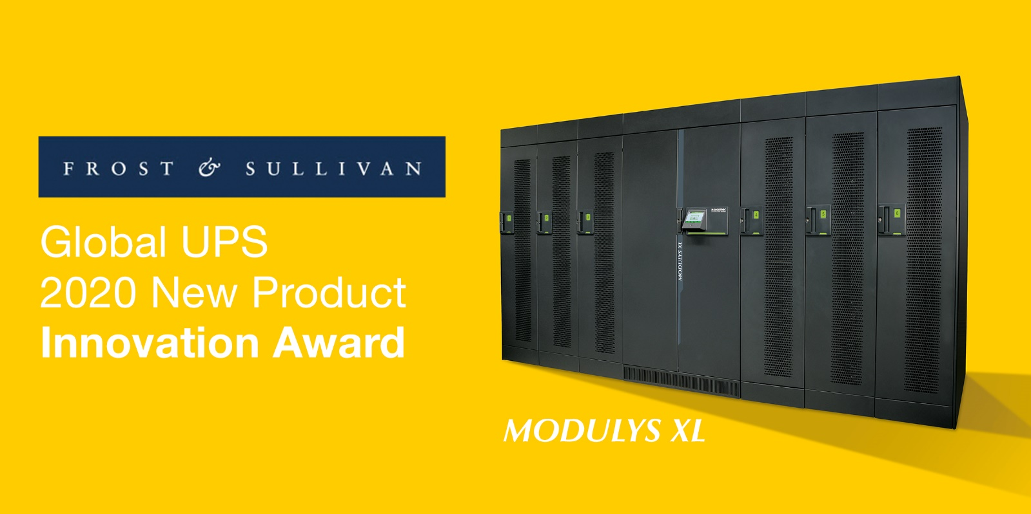

Every year, following extensive research and analysis, the independent body selects industry-leading businesses and products that demonstrate excellence in innovation and that leverage developmental technologies, offer real value, clear benefits and support customers’ return on investment.
Identified by Frost & Sullivan as having the potential to emerge as the most sought after modular UPS product, this latest accolade is testament to Socomec’s ongoing commitment to research and development in order to create designs that are directly inspired and influenced by evolving customer needs.
Frost & Sullivan observed that whilst achieving excellence in new product innovation is never an easy task, and it is made even more difficult considering today’s competitive intensity, customer volatility, and economic uncertainty—not to mention the difficulty of innovating in an environment of escalating challenges to intellectual property.

Genuine modularity in the high-power range – fine-tuned to precise project requirements
The Frost & Sullivan report observed that; “The company has a track record of developing products and solutions that perfectly align with end users’ current needs as well as anticipated future requirements. The core philosophy behind the development of this cutting-edge product was to offer end users genuinely true modularity in the high-power range. The product offers the best of both worlds; it provides the highest degree of flexibility that comes with a tailored custom solution and on the other hand, it also offers the benefits of standardised assets - allowing end users to fine tune the system to match the exact project requirements.”
The MODULYS XL is based on 200KW power modules, where a single unit can be scaled up to 1.2MW while allowing up to 4 units to be configured in parallel.
(Name), (Title), Socomec comments; “With the modular UPS market still in growth, there has been an irony in this field as many solutions have not, to date, always delivered in terms of modularity, leading to nervousness around the concept. We wanted to shatter those perceptions and create a completely new breed of high power modularity. We have put the customer and the user at the heart of this development programme – and we have dedicated our R&D efforts to create products that address unmet gaps.
Frost & Sullivan comment; “While designing the MODULYS XL, Socomec has taken utmost care to achieve the optimum level of granularity by striking a perfect balance between mean time between failure and intrinsic redundancy. By doing so, it is able to effectively eliminate power module losses caused by missing modules or hiked up service costs caused by adding more modules than necessary. The MODULYS XL achieves all this while still offering simple and easy serviceability (similar to that of smaller modules). In simple terms, it offers hot-scalability along with rapid, safe and concurrent maintenance whilst maintaining reliability at highest magnitudes due to right sizing power modules.”
The Modulys XL offers end users much needed configuration flexibility and simplifies the overall process from project definition to the UPS being fully operational – delivering value in terms of product, solution and process.

SOCOMEC: When energy matters |  | Press contact
Founded in 1922, SOCOMEC is an independent industrial group with a workforce of 3600 experts spread over 28 subsidiaries in the world. Our core business: the availability, control and safety of low voltage electrical networks serving our customers’ power performance. In 2019, SOCOMEC posted a turnover of 572M€*.  *estimated 2019 |  | Firstname Lastname  Function  Phone number  Mobile Number  xxxxxxxx@socomec.com  www.socomec.co.uk

