Powering the digital world
City, Date xx^{th}, 2022
Revealing the latest solutions to guarantee power for our digital world, Socomec will be showcasing its most recent developments at Data Centre World 2022, London ExCel 2nd – 3rd March 2022.
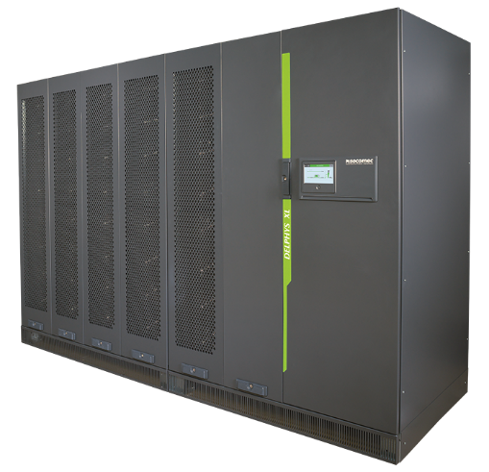 | Integrated power specialist, Socomec, is introducing a new wave of innovation that ensures power availability and energy performance, on show at Data Centre World, London, 2nd – 3rd March 2022.  Today’s critical infrastructures need to accommodate rapid deployment requirements and system upgrades, while maintaining maximum availability. Furthermore, rapidly rising energy costs and a premium on floor space mean that every facility is focused on efficiency and usage – and reducing operating expenditure.

Delphys XL 1200 kW: Socomec’s new high power UPS
Achieving very high efficiencies is vital when it comes to making a significant reduction in the operational costs of a data centre. Socomec’s Delphys XL combines several-advanced working mode optimizing efficiencies without sacrificing power quality.

Resiliency that’s rightsized: saving floor space and eliminating single points of failure
Delphys XL is a highly compact and efficient UPS designed to secure the most critical applications, offering inherent redundancy and allowing by design, fast & safe maintenance operation.
Based on Socomec’s high power XL platform – a power architecture with field-proven reliability - and leveraging the strengths and uniqueness of the XL architecture, the Delphys XL provides outstanding resiliency by eliminating traditional monolithic UPS single points of failure.
Design for serviceability
Based on our modular expertise, Delphys XL has been engineered with the ease of serviceability and the security of maintenance in mind. Supporting low MTTR through an innovative and unique service concept
For when energy matters most to you and to learn how Socomec could guarantee the performance of your new or existing infrastructure, visit the team at Data Centre World, March 2nd – 3rd, Stand D1025.

SOCOMEC: When energy matters |  | Press contact
Founded in 1922, SOCOMEC is an independent industrial group with a workforce of 3600 experts spread over 28 subsidiaries in the world. Our core business: the availability, control and safety of low voltage electrical networks serving our customers’ power performance. In 2020, SOCOMEC posted a turnover of 544,4M€. |  | Web: www.socomec.co.uk  Email: info.uk@socomec.com  LinkedIn : Socomec Group

