The future of power monitoring

Benfeld, March 2018

The latest developments from Socomec are delivering smarter buildings and facilities with sustainable and intelligent energy solutions.

Equipped for the smart facilities of today – and tomorrow – Socomec’s product developments are connecting the world of energy with the digital revolution to help reduce installation costs and improve performance levels, securing power and making energy management simple across critical applications.

Groundbreaking technologies for greater simplicity and performance
The future of power monitoring has now been reinvented, with three additional new technologies available with both the DIRIS A-40 and DIRIS Digiware systems for unsurpassed levels of accuracy.

PreciSense: Products that are setting new standards in measurement accuracy
PreciSense technology ensures 100% reliable accuracy over the entire measuring chain.

Be guaranteed of the accuracy of your measurements:
- For the global measurement chain.
- For reliable measurements.
- For relevant corrective actions.

PreciSense technology offers the best accuracy on the market regardless of the type of current sensors used (solid, split-core, flexible or embedded in the DIRIS Digiware S module).

Discover the video

VirtualMonitor: The simple and cost-saving solution for monitoring your protective devices
Virtual Monitor technology enables a monitoring solution to be installed simply and at all levels of the installation.

Virtual Monitor:
- Detects the position and status of the device.
- Detects tripping of the protective device.
- Meters the number of operations.

VirtualMonitor technology monitors the status of protective devices:
- On your entire electrical installation (without additional space).
- Remotely and in real-time.
- Without additional hardware or wiring (without adding an auxiliary contact).

Discover the video

AutoCorrect: The software that eliminates wiring errors
AutoCorrect technology ensures that the equipment is properly wired at all times, thus avoiding on-site inspections.

AutoCorrect technology ensures the operation of the measuring system thanks to simple and rapid detection of connection errors:
- Automatic wiring control (phase sequence detection and automatic configuration of the direction of the current).
- Correction of errors with a single click.
- Feature available off-load.

Error correction is carried out without any modification to the wiring.

Discover the video

PreciSense, VirtualMonitor and AutoCorrect technologies are embedded in Socomec’s power monitoring devices.

DIRIS Digiware
Power metering and monitoring system for AC and DC electrical installations

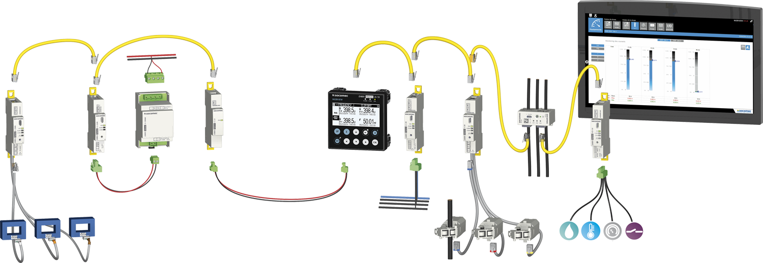

DIRIS A-40
Multifunction meters
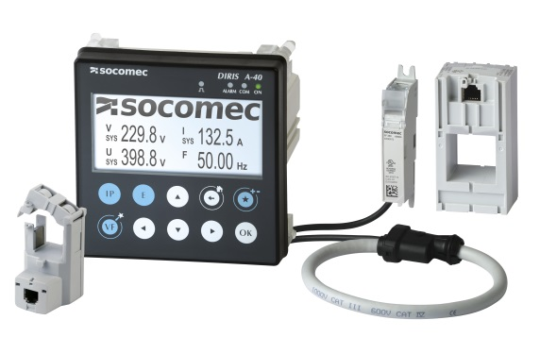
Learn more: http://www.socomec.fr/energy-efficiency_en.html

ABOUT SOCOMEC |  | MORE INFORMATION
Founded in 1922, SOCOMEC is an independent, industrial group with a workforce of 3100 people spread over 27 subsidiaries in the world. Our core business – the availability, control and safety of low voltage electrical networks with increased focus on our customers’ power performance. In 2016, SOCOMEC posted a turnover of 480 M€. |  | Press contact  Virginie GUYOT  MarCom Manager  E-mail : virginie.presse@socomec.com  www.socomec.fr

